**An IoT Based Smart Parking System**

**Abstract.**

This paper aims to provide a user friendly, reliable and automated car parking system Even if known; many vehicles may pursue very limited parking spaces to cause serious traffic congestion. In this paper, we design and implement a prototype of Smart Parking System The automatic car parking system is totally automated with the user being given a unique ID corresponding to the trolley being allocated to him or her this kind of equipment is useful to solve the issue of limited parking space available is busy cities. With the increase of economic behavior and the upgrade of living standard, the ratio of people in India who own automobiles and motorcycles have recently increased giving a boost to Metropolitan Traffic. Therefore, parking issues will be a big challenge to facilitate traffic network and ensure urban life quality. Searching for parking space in most metropolitan areas, especially during the rush hours, is difficult for drivers. The difficulty arises from not knowing where the available spaces may be at that time.

**Keyword**- design automation, load modeling, Mechanical parking system

1. **Introduction**

In this current era of modern world, almost everyone owns a personal vehicle and it has become a basic need for the humans. Hence, it has been proven statistically that the usage of vehicles is increasing rapidly yearly [1]. Due to the growth, it is very difficult to find parking slots in cities, especially during the peak time.

This creates a necessity to introduce an automated system that allows users to book their spot just by making a few clicks through a custom made Android Mobile Application. This serves to hassle free situation for each and every users. The main motivation behind the Smart Parking System is to help the drivers to find areas where parking is available in that area [2]. Prior to his expected arrival, drivers can book a slot in the area if it is available. Drivers can search the parking slot through the mobile application installed and book the available slot. Besides that, user can also view the duration of parking usage through the application and charges can be calculated through the online application sent to the user for notification. Not only this, user can opt to extend their duration by simply requesting on the application by few clicks. All you need is a working Internet.

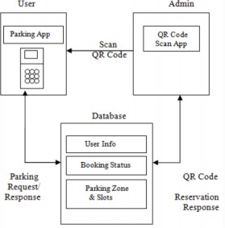

**2.Literature Review**

According to previous related works, there are several methods used to develop the system. It is highly crucial to have knowledge on the systems that have been developed in order to ensure a better enhancement of the proposed system in this project. In some studies [3], image processing is given more importance instead of sensor based system. Driver’s number plate is captured by Image processing is used to capture the number plate of the drivers and the information is stored in database. This is to avoid theft and illegal car entry. The users must register first before using the Android application. This application consists of basic information of the drivers which will be stored for future references. After registration, the driver is required to select the parking location and the server will immediately process the data received and sends back the information needed to the user. Next, an innovative approach came as a solution for the reservation traffic in where QR code is taken into account for reservation confirmation. In research paper [4] “Smart Parking System based on Reservation”, states that the expansion of monetary conduct for everyday comfort has rapidly increases the ratio of people who owns vehicles giving boost to busy cities traffic. This is commonly why traffic congestion and air pollution occurs. The management will system will broadcast the details on the available parking slots to drivers. Then, the drivers will select a particular parking slot to book. As soon as the driver reserve the slot, the server generates a unique QR code and quickly sends it to the drivers. After placing the reservation, the host will demand for the QR code sent to the user to verify details sent before and let the user to use the reserved place. This code stores in information such as parking charge and the availability of the slot for the both user and provider for reference. The hardware part of this system is divided into three main parts; QR scanner, server and mobile phone. Figure 1 illustrates the layout of the parking system in brief.



Figure 1: Layout of Parking System

**3.Methodology**

Methodology is a model to explain the methods or techniques used to design, develop or plan a project. This chapter explains about the software and hardware that will be used for developing this project further. The results are going to be analyzed to achieve the objective of this project.

**3.1 System Overview**

The proposed system is used to indicate the user about the vacancy of the parking slots. A user can choose the parking slot in advance, instead of waiting in area of the parking, where the parking availability are shown through user’s smart phones. IR Sensors will be attached in each slot for detecting the vacancy. The signal from the sensors captured by Arduino and these signal is then converted from electrical signal into another form to detect presence of vehicle in terms of the amount of light reflected back from the obstacle such as wall of the parking lot. The output from Arduino depends on the measurement of amount of light and based on that, slot’s allocation is done. On the other hand, the output from Arduino is changed into text format and sent to the smart phones through a developed Android application. Now the users are provided with the parking details and can choose the appropriate slots to reserve.

Besides reservation, user also will be notified on details of parking such as extending or making payment via a simple text message with the help of GSM. The parking area are sensed by using the sensors which are placed in each slot. The sensors will detect each slot as input and the output of the sensors is preceded to the Arduino. Arduino will process the input of the sensors, analog to digital conversion are made and by tracking the user using the details of the parking slots given to the user. The components needed for this project are sensing device, communication platform and mobile application. Figure 2 shows the proposed block diagram of smart parking system.

**3.2 Block Diagram**

Figure 2 shows the block diagram of the proposed smart parking system.

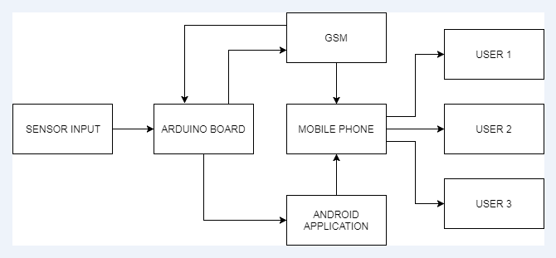

Figure 2: Block Diagram

**3.3 Flowchart**

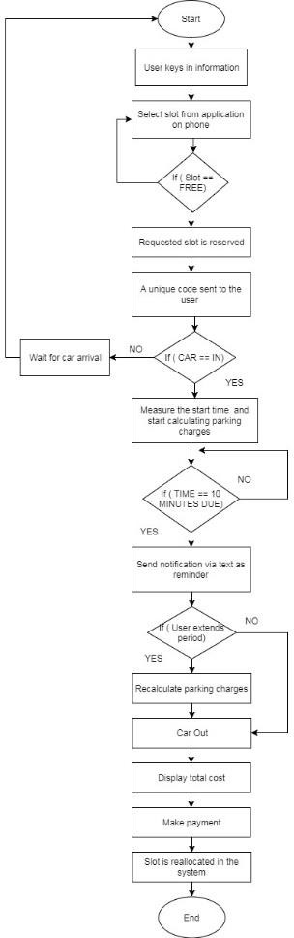

Figure 3: Flowchart of the System

Figure 3 explains the flowchart of the project. The process flow of the smart parking system when users start initialization through mobile application. Users are required to key-in important details such as name, vehicle’s plate number, contact number and duration they want to park for. Once registered, users are taken into the next window where availability of slots based on real time. Red indicates the slots are occupied whereas green indicates free occupancy, thus users can choose to reserve them.

Normal users go through the normal ticketing process. Once the car enters in the parking bay, it starts to calculate the time and also parking charges. Else, wait for the car arrival within the time allocated. Next, when the time of the parking is 10 minutes due, a notification is sent to the user as a reminder where user can opt to extend their parking duration for a certain time and parking charges are recalculated. If no, car must exit from the parking lot. This is where the Android app will display the total cost, user can make payment. The slot will be reallocated in the system again.

**3.4 Related Hardware Tools**

IR Sensors will be attached in each slot to detect the presence of the vehicles. [7] This sensor detects the presence of a vehicle in terms of the amount of light reflected back from the obstacle and in this case it will be the wall of the parking slot. If no obstacle is present, IR light cannot be detected by the sensor. The typical Infrared Transmitter found is a Light Emitting Diode (LED) which functions by emitting infrared pulse.

Arduino Uno Wi-Fi board is integrated with Wi-Fi module which will be used in this project. This board is based on integrated ESP8266 Wi-Fi Module and ATmega328P. The Wi-Fi module has TCP/IP Protocol stack which gives direct access to the Wi-Fi network [8]. This board is programmed by using Arduino IDE software. This board is ideal as it can run both in online and offline mode.

A GSM module is used to communicate between a mobile device and a computer. GSM operates at 850MHz, 900MHz, 1800MHz and 1900MHz frequency bands to transmit mobile data services. GSM has many features such as international roaming, high quality speech, SIM phonebook and also short message service (SMS) [8]. GSM is considered very secure telecommunication available now. GSM is used to transmit SMS from sender to receiver. In this project, SMS is sent to the user to notify them that the duration of the parking hours is going to end.

**4.Result**

The process flow of the smart parking system when users start initialization through mobile application. Users are required to key-in important details such as name, vehicle’s plate number and contact number. Figure 4 shows the layout of the Android Application for the login page.

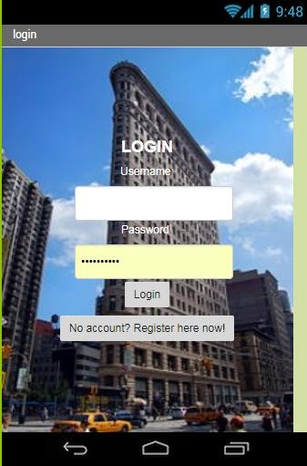

Figure 4: Layout of Android Application

The process flow of the smart parking system when users start initialization through mobile application. Users are required to key-in important details such as name, vehicle’s plate number, contact number and duration they want to park for. Once registered, users are taken into the next window where availability of slots based on real time. Red indicates the slots are occupied whereas green indicates free occupancy, thus users can choose to reserve them. Then, user will be sent a unique code which later on they have to scan at the entrance of parking bay within the time given. The unique code differentiates between the mobile users and normal users. Normal users go through the normal ticketing process. Once the car enters in the parking bay, it starts to calculate the time and also parking charges. Else, wait for the car arrival within the time allocated. Next, when the time of the parking is 10 minutes due, a notification is sent to the user as a reminder where user can opt to extend their parking duration for a certain time and parking charges are recalculated. If no, car must exit from the parking lot. This is where the Android app will display the total cost, user can make payment. The slot will be reallocated in the system again. Figure 5 shows the hardware components used for this project.

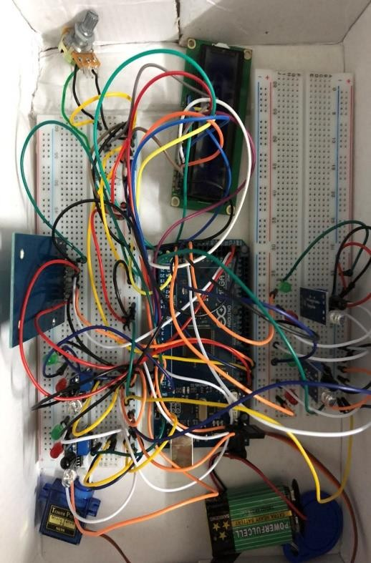

a. Figure 5: Hardware used in the Project

**5.Conclusion**

This system is to ease the drivers to find parking slots during peak hours by using Android Application. This is an efficient system as it helps to solve heavy traffic congestion and reduces the driver’s frustrations. The system can be more enhanced by providing the route to the selected parking location with the help of Global Position Search (GPS) System.).

**6.References**

* P. Mane, R. Deoghare, S. Nagmote, S. Musle, and S. Sarwade, “Android based Smart Parking System,” pp. 3981–3985, 2015.
* R. Renuka and S. Dhanalakshmi, “Android Based Smart Parking System Using Slot Allocation & Reservations,” vol. 10, no. 7, pp. 3116–3120, 2015.
* M. Computing, “Smart Car Parking Using Arduino,” vol. 5, no. 2, pp. 230–234, 2016.
* M. S. Rahul Patil,”Smart parking system based on reservation,”vol.2, Mumbai,India, 2014.
* T. N. A. M. Pham, M. Tsai, and D. U. C. B. Nguyen, “A Cloud-Based Smart-Parking System Based on Internet-of-Things Technologies,” pp. 1581–1591, 2015.
* S. A. El-seoud, H. El-sofany, and I. Taj-eddine, “Towards the Development of Smart Parking System using Arduino and Web Technologies,” no. 978, pp. 10–16, 2016.
* R. H. Giva Andriana, Anak Agung, “Sensor Comparation for Smart Parking System,” pp. 4–9, 2012.
* N. Hazrin, H. Mohamad, M. H. Badiozaman, and H. Daud, “Smart Parking Reservation System using Short Message Services (SMS),” 2008.